Day 12
Task 1:
A Database Management System (DBMS) is needed to efficiently store, manage, retrieve, and manipulate large amounts of data. Before DBMS, data was stored in separate files, which led to many problems.
Task 2:
Traditional file systems are difficult to manage, secure, and maintain, whereas a DBMS provides efficient, reliable, and centralized data management.
Task 3:
Data Independence is the ability to change the database structure at one level without affecting the structure at the next higher level. It allows modifications in the database without requiring changes to application programs.
Task 4:
A database model defines how data is structured, stored, and related within a database system.
- Hierarchical Database Model
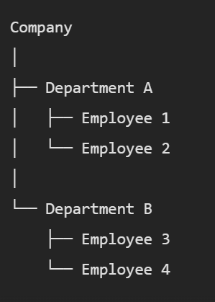
- Network Database Model
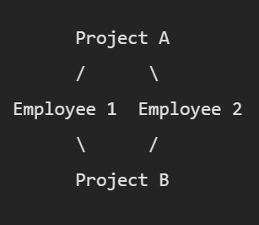
- Relational Database Model
- Object-Oriented Database Model
class Student {
int studentID;
String name;
String course;
}

Task 5:
Concurrency Control is a mechanism in a DBMS that manages the simultaneous execution of multiple transactions without causing data inconsistency. It ensures that multiple users can access and modify the database at the same time while maintaining the correctness and integrity of data.
Task 6:
An index is a data structure used by a DBMS to speed up the retrieval of records from a database table. It works similarly to the index of a book, which helps you quickly find the required information without scanning every page.
Without an index, the DBMS must perform a full table scan, checking every row to find the required data.
Task 7:
A deadlock is a situation in a DBMS where two or more transactions are waiting indefinitely for each other to release resources, and none of them can proceed.
Task 8:
The Relational Model is a database model in which data is organized into tables (relations) consisting of rows (tuples) and columns (attributes).
Task 9:
An RDBMS stores data in the form of related tables.
Important RDBMS terms include Table, Row (Tuple), Column (Attribute), Domain, Primary Key, Foreign Key, Candidate Key, Alternate Key, Composite Key, Schema, Instance, Relationship, Normalization, and SQL.
Task 10:
The most important keys in RDBMS are Primary Key, Foreign Key, Candidate Key, Alternate Key, Composite Key, Super Key, and Unique Key. These keys help ensure data integrity, uniqueness, and proper relationships between tables.

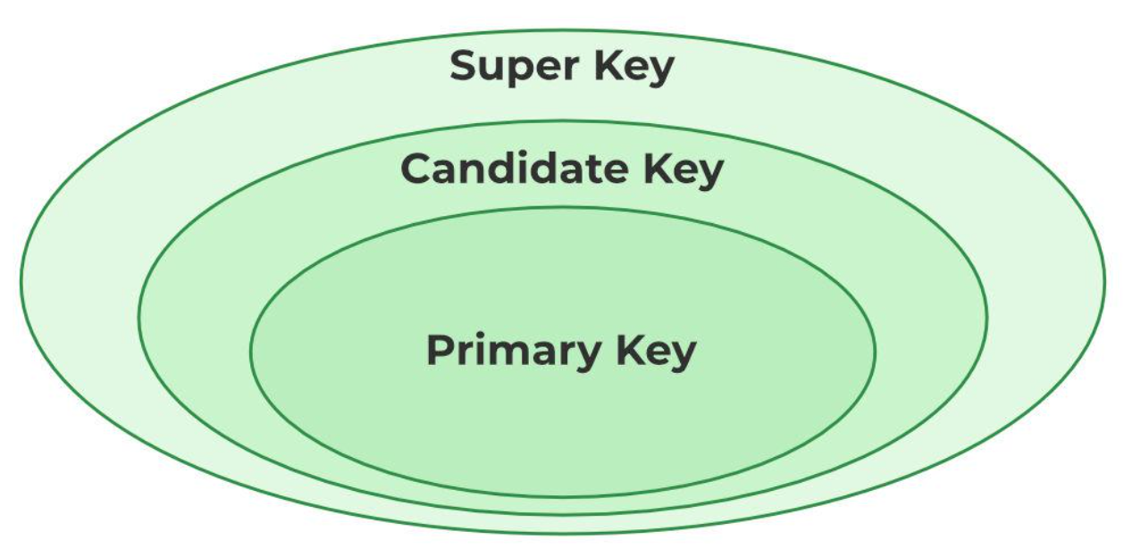
Task 11:
- Primary Key: Uniquely identifies each record and cannot contain NULL values.
- Foreign Key: Connects one table to another by referencing a primary key.
- Unique Key: Ensures that all values in a column are unique but is not necessarily the primary identifier.
Task 12:
Transaction Management is the process of managing database transactions so that data remains consistent, accurate, and reliable, even when system failures or errors occur.
A transaction is a sequence of one or more database operations treated as a single unit of work.
Eg: Consider transferring ₹5,000 from Account A to Account B.
Steps involved:
- Deduct ₹5,000 from Account A.
- Add ₹5,000 to Account B.
Both operations must be completed successfully. If one operation fails, the entire transaction should be cancelled.
Task 13:
Normalization is a database design technique used to organize data into well-structured tables, minimizing redundancy and maintaining consistency. It is necessary because it improves data integrity, reduces storage waste, and prevents anomalies during data insertion, updating, and deletion.
Task 14:
1NF (First Normal Form) is the first level of database normalization. A table is said to be in 1NF if:
- Each column contains atomic (single) values.
- There are no repeating groups or multiple values in a single column.
- Each row is unique and can be identified by a primary key.
Task15:
2NF (Second Normal Form) is the second step of database normalization.
A table is in 2NF if:
- It is already in 1NF.
- Every non-key attribute is fully dependent on the entire primary key, not just part of a composite key.
Task 16:
3NF (Third Normal Form) is the third step of database normalization.
A table is in 3NF if:
- It is already in 2NF.
- There are no transitive dependencies, meaning non-key attributes should not depend on other non-key attributes.
- Every non-key attribute should depend only on the primary key.
Task 17:
Joins in SQL are used to combine rows from two or more tables based on a related column between them. They help retrieve data stored across multiple tables in a relational database.
- INNER JOIN
Returns only the matching records from both tables.

SELECT E.EmpID, E.EmpName, D.DeptName
FROM Employees E
INNER JOIN Departments D
ON E.DeptID = D.DeptID;

- LEFT OUTER JOIN (LEFT JOIN)
Returns all records from the left table and matching records from the right table. If no match exists, NULL values are returned for the right table columns.
SELECT E.EmpID, E.EmpName, D.DeptName
FROM Employees E
LEFT JOIN Departments D
ON E.DeptID = D.DeptID;

- RIGHT OUTER JOIN (RIGHT JOIN)
Returns all records from the right table and matching records from the left table.

SELECT E.EmpID, E.EmpName, D.DeptName
FROM Employees E
RIGHT JOIN Departments D
ON E.DeptID = D.DeptID;

- FULL OUTER JOIN
Returns all records from both tables. Matched rows are combined, and unmatched rows show NULL values.

SELECT E.EmpID, E.EmpName, D.DeptName
FROM Employees E
FULL OUTER JOIN Departments D
ON E.DeptID = D.DeptID;

- CROSS JOIN
Returns the Cartesian product of both tables, meaning every row from the first table is combined with every row from the second table.
SELECT E.EmpName, D.DeptName
FROM Employees E
CROSS JOIN Departments D;

- SELF JOIN
A table is joined with itself.
SELECT E.EmpName AS Employee,
M.EmpName AS Manager
FROM Employees E
LEFT JOIN Employees M
ON E.ManagerID = M.EmpID;

